EXP 3:

FIGMA:

The stakeholders have conflicting views on the user interface design for an E-Commerce mobile app. Create a prototype using Figma tool to discuss with the stakeholders to get their feedback and approval.

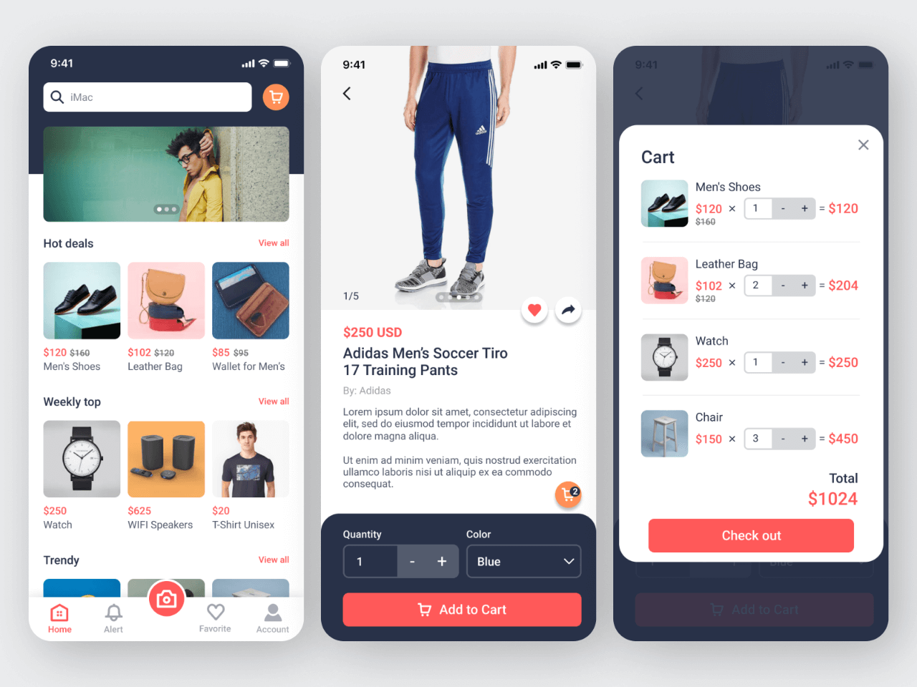

EXP 5:

GOOGLE/EXCEL SHEETS:

Use the following requirements for a Library Management System:

• Add a feature to search books by title and author.

• Implement an online book reservation system.

• Generate monthly reports on borrowed books for administrators.

• Enable email notifications for overdue books.

• Add support for QR code scanning for borrowing and returning books.

• Create a user-friendly dashboard for librarians.

• Allow users to review and rate books.

• Integrate a chatbot for user assistance.

• Develop a mobile app version of the system.

• Provide multi-language support. Categorize each requirement using MOSCOW Method (Must-Have, Should-Have, Could-Have, or Won’t-Have) based on the following criteria:

• Impact on the users and stakeholders.

• Feasibility considering time, budget, and resource constraints. Finally Submit the completed Google Sheet or Excel file with all requirements categorized and justified.

| **Requirement** | **Category (MOSCOW)** | **Justification** |
| --- | --- | --- |
| Search books by title and author | Must-Have | Fundamental feature expected by users and stakeholders. |
| Implement an online book reservation system | Must-Have | Critical for remote access and convenience for users. |
| Generate monthly reports for administrators | Must-Have | Key for library operations and decision-making. |
| Enable email notifications for overdue books | Should-Have | Improves user engagement and helps reduce overdue instances. |
| Add support for QR code scanning | Should-Have | Enhances the borrowing and returning experience but may need hardware support. |
| Create a user-friendly dashboard for librarians | Must-Have | Essential for library staff to manage the system effectively. |
| Allow users to review and rate books | Could-Have | Adds value but is not essential for core library functionality. |
| Integrate a chatbot for user assistance | Could-Have | Useful for user convenience but may require additional resources to implement. |
| Develop a mobile app version of the system | Should-Have | Increases accessibility but requires extra time and resources. |
| Provide multi-language support | Could-Have | Enhances usability for diverse users but may not be feasible initially. |
|  |  |  |

**Categorized Requirements:**